Puru Sai Koushik
2200032991

WEEK-4 spring-rest-handson
Spring Core – Load Country from Spring Configuration XML

Output the data format
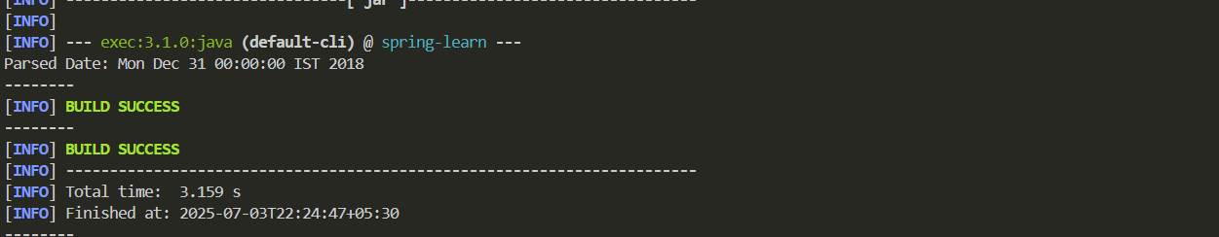
date-format.xml
<?xml version="1.0" encoding="UTF-8"?>
<beans xmlns="http://www.springframework.org/schema/beans"
xmlns:xsi="http://www.w3.org/2001/XMLSchema-instance"
xsi:schemaLocation="http://www.springframework.org/schema/beans
https://www.springframework.org/schema/beans/spring-beans.xsd">

<bean id="dateFormat" class="java.text.SimpleDateFormat">
<constructor-arg value="dd/MM/yyyy" />
</bean>

</beans>

SpringLearnApplication.java
package com.example.springlearn;

import java.text.ParseException;
import java.text.SimpleDateFormat;
import java.util.Date;

import org.springframework.context.ApplicationContext;
import org.springframework.context.support.ClassPathXmlApplicationContext;

public class SpringLearnApplication {

public static void main(String[] args) throws ParseException {
displayDate();
}

public static void displayDate() throws ParseException {
ApplicationContext context = new ClassPathXmlApplicationContext("date-format.xml");
SimpleDateFormat format = context.getBean("dateFormat", SimpleDateFormat.class);
Date date = format.parse("31/12/2018");
System.out.println("Parsed Date: " + date);
}
}

